**Name: Sanjay Tharagesh R S**

**Roll: CB.EN.U4CSE17453**

**Drive link for other codes:** <https://drive.google.com/drive/folders/13CA_UXGJiEEPDiSoE5ZHSQrr43dmZyT7?usp=sharing>

**IndexForm.html**

<!DOCTYPE html>

<html>

<head>

<meta charset=*"ISO-8859-1"*>

<title>Form</title>

</head>

<body>

<form method=*"post"* class=*"login-form"* style="text-align: *left*; padding-left: *10%*;">

<p class=*"ques"*>Sign Up</p>

<input type=*"text"* id=*"fname"* name=*"fname"* placeholder=*"First Name"*>

<input type=*"text"* id=*"lname"* name=*"lname"* placeholder=*"Last Name"*>

<br>

<input type=*"password"* id=*"pword"* name=*"pword"* pattern=*"(?=.*\d)(?=.*[a-z])(?=.*[A-Z]).{8,}"* title=*"Must contain at least one number and one uppercase and lowercase letter, and at least 8 or more characters"* placeholder=*"Passowrd"* required>

<br>

<p class=*"ques"*>Choose your Gender</p>

<input type=*"radio"* id=*"male"* name=*"gender"* value=*"male"*>

<label for=*"male"*>Male</label><br>

<input type=*"radio"* id=*"female"* name=*"gender"* value=*"female"*>

<label for=*"female"*>Female</label><br>

<input type=*"radio"* id=*"other"* name=*"gender"* value=*"other"*>

<label for=*"other"*>Other</label>

<br>

<p class=*"ques"*>Choose your Vehicle type for parking</p>

<input type=*"checkbox"* id=*"bike"* name=*"vehicle"* value=*"bike"*>

<label for=*"bike"*> I have a bike</label><br>

<input type=*"checkbox"* id=*"car"* name=*"vehicle"* value=*"car"*>

<label for=*"car"*> I have a car</label><br>

<input type=*"checkbox"* id=*"boat"* name=*"vehicle"* value=*"boat"*>

<label for=*"boat"*> I have a boat</label>

<br>

<label for=*"dob"*>Date of Birth:</label>

<input type=*"date"* id=*"dob"* name=*"dob"*>

<br>

<label for=*"email"*>Enter your Email:</label>

<input type=*"email"* id=*"email"* name=*"email"* placeholder=*"xyz@yahoo.co.in"*>

<br>

<label for=*"myfile"*>Choose Photo to upload:</label>

<input type=*"file"* id=*"photo"* name=*"photo"* value=*"photo"*>

<br>

<label for=*"family_members"*>Numer of Family members (max - 10):</label>

<input type=*"number"* id=*"family_members"* name=*"family_members"* min=*"1"* max=*"10"*>

<br>

<label for=*"portfolio"*>Your Portfolio URL: </label>

<input type=*"url"* id=*"portfolio"* name=*"portfolio"* placeholder=*"xys.com"*>

<br>

<input type=*"checkbox"* id=*"terms"* name=*"terms"* value=*"terms"* required>

<label for=*"terms"*> Agree to terms and conditions</label><br>

<button type=*"submit"*>SUBMIT</button>

<button type=*"reset"*>RESET</button>

</form>

</body>

</html>

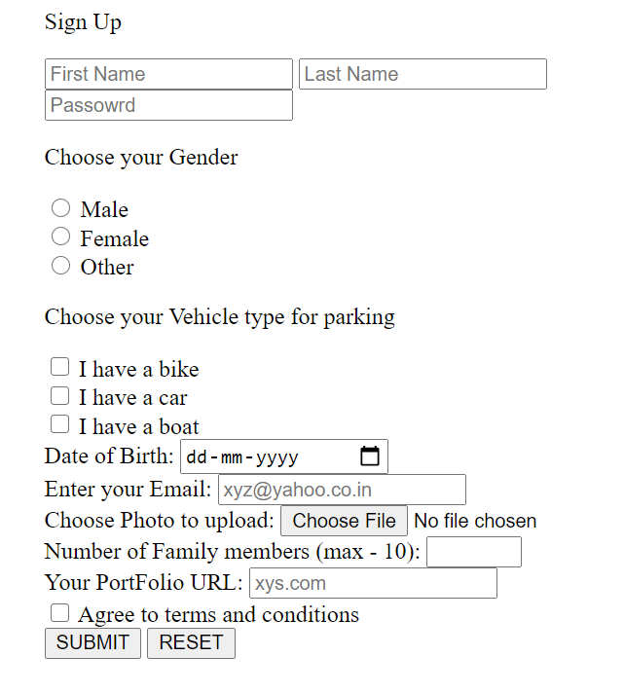

**MyServletDemo.java**

**import** java.io.*;

**import** javax.servlet.*;

**import** javax.servlet.http.*;

// Extend HttpServlet class to create Http Servlet

**public** **class** MyServletDemo **extends** HttpServlet {

**private** String mymsg;

**public** **void** init() **throws** ServletException {

mymsg = "Hello World!";

}

**public** **void** doGet(HttpServletRequest request, HttpServletResponse response)

**throws** ServletException, IOException {

// Setting up the content type of webpage

response.setContentType("text/html");

// Writing message to the web page

PrintWriter out = response.getWriter();

out.println("<h1>" + mymsg + "</h1>");

}

**public** **void** destroy() {

/* leaving empty for now this can be

used when we want to do something at the end

of Servlet life cycle

*/

}

}

**Server Console Output**

